**Anjuman-I-Islam**

**M.H. Saboo Siddik Polytechnic**



**Java programming (jpr)**

**Microproject**

**Computer Engineering**

**Department**

**Co-4i**

**Title: Virtual private network (vpn) for an office**

**Year: 2022-23**

**PREPARED BY:**

* 210418: Abdullah Bagdadi
* 210429: Hussain Arsiwala
* 210444: Abdurrahman Qureshi

**Under the guidance of**: Ms. Zaibunnisa Malik



**MAHARASHTRA STATE**

**BOARD OF TECHNICAL EDUCATION**

**Certificate**

This is to certify that Mr. Abdullah Bagdadi Roll no. 210422 of fourth semester of Diploma in Computer Engineering of institute M.H. Saboo Siddik Polytechnic (code: 0002) has completed micro project satisfactorily in the subject: JPR (22412) for the academic year 2022-23 as prescribed in the curriculum.

Place: Byculla, Mumbai Enrolment no: 2100020…

Date: ______________ Exam seat no:

**Signature Signature Signature**

**Project guide H. O. D Principal**



SEAL OF



INSTITUDE





**MAHARASHTRA STATE**

**BOARD OF TECHNICAL EDUCATION**

**Certificate**

This is to certify that Mr. Hussain Arsiwala Roll no. 210448 of fourth semester of Diploma in Computer Engineering of institute M.H. Saboo Siddik Polytechnic (code: 0002) has completed micro project satisfactorily in the subject: JPR (22412) for the academic year 2022-23 as prescribed in the curriculum.

Place: Byculla, Mumbai Enrolment no: 2100020…

Date: ______________ Exam seat no:

**Signature Signature Signature**

**Project guide H. O. D Principal**



SEAL OF



INSTITUDE





**MAHARASHTRA STATE**

**BOARD OF TECHNICAL EDUCATION**

**Certificate**

This is to certify that Mr. Abdurrahman Qureshi Roll no. 210451 of fourth semester of Diploma in Computer Engineering of institute M.H. Saboo Siddik Polytechnic (code: 0002) has completed micro project satisfactorily in the subject: JPR (22412) for the academic year 2022-23 as prescribed in the curriculum.

Place: Byculla, Mumbai Enrolment no: 2100020…

Date: ______________ Exam seat no:

**Signature Signature Signature**

**Project guide H. O. D Principal**



SEAL OF



INSTITUDE



**Acknowledgment**

We wish to express our profound gratitude to our guide Ms. Zaibunnisa Malik Ma’am who guided us endlessly in the framing and completion of the micro project. She guided us on all the main points in that micro project. We are indebted to her constant encouragement, cJPReration, and help. It was her enthusiastic support that helped us in overcoming various obstacles in the micro-project.

We are also thankful to our Principal, HOD, faculty members and classmates of Computer Engineering department for extending their support and motivation in the completion of this micro-project.

Names of Team Members with Roll Nos.

* 210422: Abdullah Bagdadi
* 210448: Hussain Arsiwala
* 210451: Abdurrahman Qureshi

**Annexure-I**

***Micro project proposal***

**Title of micro project: Virtual private network (vpn) for an office**

1. **Aims/Benefits of micro project**

Java is a platform independent language with object-oriented features. The Micro project aims to develop a program on an assigned topic. Java being platform independent our program should run on all the machines irrespective of operating system. Developing this micro project enhances our coding skills.

1. **Course outcomes addressed**

* Develop programs using Object oriented methodology in Java
* Apply concept of inheritance for code reusability
* Develop programs using multithreading
* Implement exception handling
* Develop programs using applets and graphics
* Develop programs for handling I/O and file streams.

1. **Proposed methodology**
2. To search the information about the project. (Collect relevant data from different sources i.e. books/internet and others through surveys/interviews etc.).
3. To collect all relevant content / materials to complete the project.
4. To prepare the report of micro project.
5. To prepare presentation.
6. To deliver presentation / appear for viva-voice
7. Discussion of the given topic among group members.
8. Literature survey
9. Submission of project proposal
10. Analysis of data
11. Work divided among group members
12. Compilation of content
13. Representation
14. Editing the content as per the instructions
15. Report Preparation
16. Viva and presentation

**Annexure-I**

1. **Action Plan**

|  |  |  |  |  |
| --- | --- | --- | --- | --- |
| **Weeks** | **Details of activity** | **Planned start date** | **Planned finish date** | **Name of responsible team members** |
| 1& 2 | Discussions & finalization of topics |  |  |  |
| 3 | Preparation of abstract |  |  |  |
| 4 | Literature review |  |  |  |
| 5 | Submission of micro project proposal(Annexure -I) |  |  |  |
| 6 | Collection of information on given topic |  |  |  |
| 7 | Collection of all relevant contents |  |  |  |
| 8 | Discussion and submission of outline of the project |  |  |  |
| 9 | Analysis/execution of collected data/information and Preparation of prototypes/drawings/charts/graphs/ tables/models/circuits/programs etc. |  |  |  |
| 10 | Compilation of contents of project |  |  |  |
| 11 | Compilation of weekly progress report |  |  |  |
| 12 | Preparation of the project report (Annexure II) |  |  |  |
| 13 | Viva Voce / Delivery of presentation. |  |  |  |

1. **Resources required**

|  |  |  |  |  |
| --- | --- | --- | --- | --- |
| **Sr. no.** | **Name of resources** | **Specifications** | **Qty** | **Remarks** |
|  | Online | Learning resources and various websites | 3 sites |  |
|  | Desktop | Microsoft word, Tools with internet facility. | 1 for each |  |
|  | Software | Jdk19, Notepad, VS Code | 1 for each |  |

Names of Team Members with Roll Nos.

* 210422: Abdullah Bagdadi
* 210448: Hussain Arsiwala
* 210451: Abdurrahman Qureshi

7Approved by:

Sign of Faculty:

Name of faculty: Ms. Zaibunnisa Malik

**Annexure-II**

**Virtual private network (vpn) for an office**

1. **Rationale**

A VPN (Virtual Private Network) is a technology that allows secure communication between two or more devices over a public network such as the internet. It provides an encrypted tunnel that protects the data transmitted between the devices from unauthorized access or interception.

2.0 **Aims/Benefits of the Micro-Project:**

* Improve programming skills: Developing Virtual private network (vpn) for an office requires knowledge of various programming concepts, including object-oriented programming, algorithms, data structures, and more. By building this game, developers can improve their programming skills and gain practical experience in applying these concepts.
* Enhance problem-solving abilities: Developing a game requires breaking down the problem into smaller, more manageable parts and implementing solutions for each component. This process can help developers enhance their problem-solving abilities and gain experience in debugging and troubleshooting.
* Enhance problem-solving abilities: Developing a game requires breaking down the problem into smaller, more manageable parts and implementing solutions for each component. This process can help developers enhance their problem-solving abilities and gain experience in debugging and troubleshooting.

**3.0 Course Outcomes Achieved:**

* Develop programs using Object oriented methodology in Java
* Apply concept of inheritance for code reusability
* Develop programs using multithreading
* Implement exception handling
* Develop programs using applets and graphics
* Develop programs for handling I/O and file streams.

**4.0 Literature Review:**

* Reference book name (GUI using JAVA)
* Surveys
* Questionnaire
* Journal Articles
* Research paper, thesis or dissertation
* YouTube Videos
* Novels, plays & films
* Digital learning resource (audio, video, text, animation & images)
  1. **Actual Methodology Followed:**

**6.0 Actual Resources Used:**

|  |  |  |  |  |
| --- | --- | --- | --- | --- |
| **Sr.**  **No.** | **NameofResource/material** | **Specifications** | **Quantity** | **Remarks** |
| 1 | MS WORD | 2016 | 1 | - |
| 2 | PC | Core i3 | 1 | - |

**7.0 Outputs of the Micro-project:**

**CODE**

**import javax.swing.*;**

**import javax.swing.JFrame;**

**import java.awt.*;**

**import java.awt.event.ActionEvent;**

**import java.awt.event.ActionListener;**

**import java.awt.event.MouseAdapter;**

**import java.awt.event.MouseEvent;**

**import java.net.InetAddress;**

**import java.util.ArrayList;**

**import java.util.Random;**

**public class MP {**

**public static void main(String[] args) {**

**new Project();**

**}**

**}**

**class Project {**

**Project() {**

**new AppFrame();**

**}**

**}**

**class ServerIP extends JFrame implements ActionListener {**

**private final JRadioButton singapore = new JRadioButton("Singapore");**

**private final JRadioButton usa = new JRadioButton("United States of America");**

**private final JRadioButton uk = new JRadioButton("United Kingdom");**

**private final JRadioButton germany = new JRadioButton("Germany");**

**private final JRadioButton japan = new JRadioButton("Japan");**

**private final JLabel result = new JLabel();**

**public ServerIP() {**

**JFrame App = new JFrame("Connecting to a Server");**

**App.setSize(480, 240);**

**App.setVisible(true);**

**App.setLocationRelativeTo(null);**

**getContentPane().setBackground(Color.BLACK);**

**App.setDefaultCloseOperation(JFrame.HIDE_ON_CLOSE);**

**JLabel Title = new JLabel();**

**Title.setText("Stealth VPN");**

**Title.setBounds(190, 150, 200, 30);**

**Title.setFont(new Font("SansSerif", Font.PLAIN, 25));**

**Title.setForeground(Color.GRAY);**

**ImageIcon TitleIcon = new ImageIcon("Internet_512px.png");**

**JLabel TitleBtn = new JLabel(TitleIcon);**

**TitleBtn.setBackground(Color.GRAY);**

**TitleBtn.setBounds(120, 120, 75, 75);**

**// create radio button group**

**ButtonGroup group = new ButtonGroup();**

**group.add(singapore);**

**group.add(usa);**

**group.add(uk);**

**group.add(germany);**

**group.add(japan);**

**// add components to the content pane**

**JPanel panel = new JPanel();**

**panel.setLocation(20,100);**

**JLabel l = new JLabel("Choose a server:");**

**//l.setText("Stealth VPN");**

**l.setBounds(120, 80, 200, 30);**

**l.setFont(new Font("SansSerif", Font.PLAIN, 25));**

**l.setForeground(Color.WHITE);**

**panel.add(singapore);**

**panel.add(usa);**

**panel.add(uk);**

**panel.add(germany);**

**panel.add(japan);**

**JButton select = new JButton("Select");**

**panel.add(select);**

**panel.add(result);**

**panel.setBackground(Color.BLACK);**

**//panel.setLocation(100,100);**

**App.add(Title);**

**App.add(TitleBtn);**

**App.add(l);**

**App.add(panel);**

**// register action listener for the select button**

**App.getContentPane().setBackground(Color.BLACK);**

**select.addActionListener(this);**

**}**

**public void actionPerformed(ActionEvent e) {**

**if (singapore.isSelected()) {**

**result.setText(ipProvider(new int[]{0,1,32,255,0,255,0,255}));**

**} else if (usa.isSelected()) {**

**result.setText(ipProvider(new int[]{2,2,0,255,0,255,0,255}));**

**} else if (uk.isSelected()) {**

**result.setText(ipProvider(new int[]{2,92,0,255,0,255,0,255}));**

**} else if (germany.isSelected()) {**

**result.setText(ipProvider(new int[]{89,145,0,255,0,255,0,255}));**

**} else if (japan.isSelected()) {**

**result.setText(ipProvider(new int[]{133,150,0,255,0,255,0,255}));**

**}**

**}**

**public String ipProvider(int[] a) {**

**ArrayList<Integer> proIp = new ArrayList<>();**

**for (int i = 0; i < 4; i++) {**

**int z = 1;**

**while (z < 2) {**

**Random random = new Random();**

**int min = a[i * 2];**

**int max = a[i * 2 + 1] + 1;**

**int rn = random.nextInt(max - min) + min;**

**proIp.add(rn);**

**z++;**

**}**

**}**

**StringBuilder ip = new StringBuilder();**

**for (int i = 0; i < proIp.size(); i++) {**

**ip.append(proIp.get(i));**

**if (i != proIp.size() - 1) {**

**ip.append(".");**

**}**

**}**

**ip.insert(0, "Your new IP address is: ");**

**return ip.toString();**

**}**

**}**

**class AppFrame extends JFrame {**

**AppFrame() {**

**JFrame App = new JFrame("Stealth VPN | JPR Micro-Project");**

**App.setSize(640, 480);**

**App.setVisible(true);**

**App.setLocationRelativeTo(null);**

**getContentPane().setBackground(Color.BLACK);**

**App.setDefaultCloseOperation(JFrame.EXIT_ON_CLOSE);**

**JLabel Title = new JLabel();**

**Title.setText("Stealth VPN");**

**Title.setBounds(250, 30, 200, 30);**

**Title.setFont(new Font("SansSerif", Font.PLAIN, 25));**

**Title.setForeground(Color.GRAY);**

**ImageIcon TitleIcon = new ImageIcon("Internet_512px.png");**

**JLabel TitleBtn = new JLabel(TitleIcon);**

**TitleBtn.setBackground(Color.GRAY);**

**TitleBtn.setBounds(150, 10, 75, 75);**

**ImageIcon userIcon = new ImageIcon("user_500px.png");**

**JLabel userBtn = new JLabel(userIcon);**

**userBtn.setBackground(Color.GRAY);**

**userBtn.setBounds(10, 200, 75, 75);**

**userBtn.addMouseListener(new MouseAdapter() {**

**public void mouseClicked(MouseEvent e) {**

**JLabel ipTitle = new JLabel();**

**ipTitle.setText("Stealth VPN");**

**ipTitle.setBounds(180, 30, 200, 30);**

**ipTitle.setFont(new Font("SansSerif", Font.PLAIN, 25));**

**ipTitle.setForeground(Color.GRAY);**

**ImageIcon ipTitleIcon = new ImageIcon("Internet_512px.png");**

**JLabel ipTitleBtn = new JLabel(ipTitleIcon);**

**ipTitleBtn.setBackground(Color.GRAY);**

**ipTitleBtn.setBounds(100, 10, 75, 75);**

**String ipAdd = "Your current IP address is :";**

**try {**

**InetAddress ip = InetAddress.getLocalHost();**

**ipAdd = ip.getHostAddress();**

**} catch (Exception ipException) {**

**System.out.println("Unable to get IP");**

**}**

**JFrame ipFrame = new JFrame("Original IP Address");**

**ipFrame.setSize(480, 240);**

**ipFrame.setVisible(true);**

**ipFrame.setLocationRelativeTo(null);**

**getContentPane().setBackground(Color.BLACK);**

**ipFrame.setDefaultCloseOperation(JFrame.HIDE_ON_CLOSE);**

**JLabel IP = new JLabel();**

**IP.setText("Your Original IP Address is : " + ipAdd);**

**IP.setFont(new Font("SansSerif", Font.PLAIN, 20));**

**IP.setForeground(Color.GRAY);**

**ipFrame.getContentPane().setBackground(Color.BLACK);**

**ipFrame.add(ipTitle);**

**ipFrame.add(ipTitleBtn);**

**ipFrame.add(IP);**

**}**

**});**

**ImageIcon helpIcon = new ImageIcon("help_480px.png");**

**JLabel helpBtn = new JLabel(helpIcon);**

**helpBtn.setBackground(Color.GRAY);**

**helpBtn.setBounds(10, 300, 75, 75);**

**helpBtn.addMouseListener(new MouseAdapter() {**

**public void mouseClicked(MouseEvent e) {**

**JFrame ipFrame1 = new JFrame("Help");**

**ipFrame1.setSize(480, 240);**

**ipFrame1.setVisible(true);**

**ipFrame1.setLocationRelativeTo(null);**

**getContentPane().setBackground(Color.BLACK);**

**ipFrame1.setDefaultCloseOperation(JFrame.HIDE_ON_CLOSE);**

**JLabel ipTitle11 = new JLabel();**

**ipTitle11.setText("Stealth VPN");**

**ipTitle11.setBounds(180, 30, 200, 30);**

**ipTitle11.setFont(new Font("SansSerif", Font.PLAIN, 25));**

**ipTitle11.setForeground(Color.GRAY);**

**ImageIcon ipTitleIcon1 = new ImageIcon("Internet_512px.png");**

**JLabel ipTitleBtn1 = new JLabel(ipTitleIcon1);**

**ipTitleBtn1.setBackground(Color.GRAY);**

**ipTitleBtn1.setBounds(100, 10, 75, 75);**

**JLabel ipTitle1 = new JLabel();**

**ipTitle1.setText("Select your desired country and check the IP Address");**

**ipTitle1.setBounds(180, 30, 200, 30);**

**ipTitle1.setFont(new Font("SansSerif", Font.PLAIN, 18));**

**ipTitle1.setForeground(Color.GRAY);**

**ipFrame1.getContentPane().setBackground(Color.BLACK);**

**ipFrame1.add(ipTitle11);**

**ipFrame1.add(ipTitleBtn1);**

**ipFrame1.add(ipTitle1);**

**}**

**});**

**ImageIcon wIcon = new ImageIcon("world_500px.png");**

**JLabel wBtn = new JLabel(wIcon);**

**wBtn.setBackground(Color.GRAY);**

**wBtn.setBounds(200, 70, 300, 300);**

**ImageIcon cIcon = new ImageIcon("country_500px.png");**

**JLabel cBtn = new JLabel(cIcon);**

**cBtn.setBackground(Color.GRAY);**

**cBtn.setBounds(10, 100, 75, 75);**

**cBtn.addMouseListener(new MouseAdapter() {**

**public void mouseClicked(MouseEvent e) {**

**// Frame ipFrame12 = new JFrame("Select Country");**

**// ipFrame12.setSize(480, 240);**

**// ipFrame12.setVisible(true);**

**// ipFrame12.setLocationRelativeTo(null);**

**// getContentPane().setBackground(Color.BLACK);**

**// ((JFrame) ipFrame12).setDefaultCloseOperation(JFrame.HIDE_ON_CLOSE);**

**final JRadioButton singapore = new JRadioButton("Singapore");**

**final JRadioButton usa = new JRadioButton("United States of America");**

**final JRadioButton uk = new JRadioButton("United Kingdom");**

**final JRadioButton germany = new JRadioButton("Germany");**

**final JRadioButton japan = new JRadioButton("Japan");**

**final JButton select = new JButton("Select");**

**final JLabel result = new JLabel();**

**ServerIP serverIP = new ServerIP();**

**serverIP.setVisible(true);**

**//((JFrame) ipFrame12).getContentPane().setBackground(Color.BLACK);**

**}**

**});**

**JButton CloseBtn = new JButton("Close");**

**CloseBtn.setBackground(Color.GRAY);**

**CloseBtn.setForeground(Color.BLACK);**

**CloseBtn.setFont(new Font("SansSerif", Font.PLAIN, 16));**

**CloseBtn.setBorder(BorderFactory.createEmptyBorder());**

**CloseBtn.setBounds(510, 400, 100, 30);**

**CloseBtn.addActionListener(new ActionListener() {**

**public void actionPerformed(ActionEvent e) {**

**System.exit(0);**

**}**

**});**

**App.getContentPane().setBackground(Color.BLACK);**

**App.add(Title);**

**App.add(TitleBtn);**

**App.add(cBtn);**

**App.add(wBtn);**

**App.add(userBtn);**

**App.add(helpBtn);**

**App.add(CloseBtn);**

**}**

**}**

**OUTPUT**

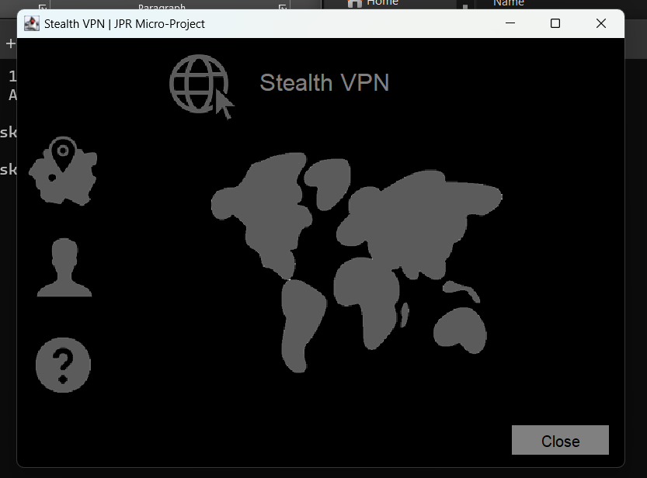

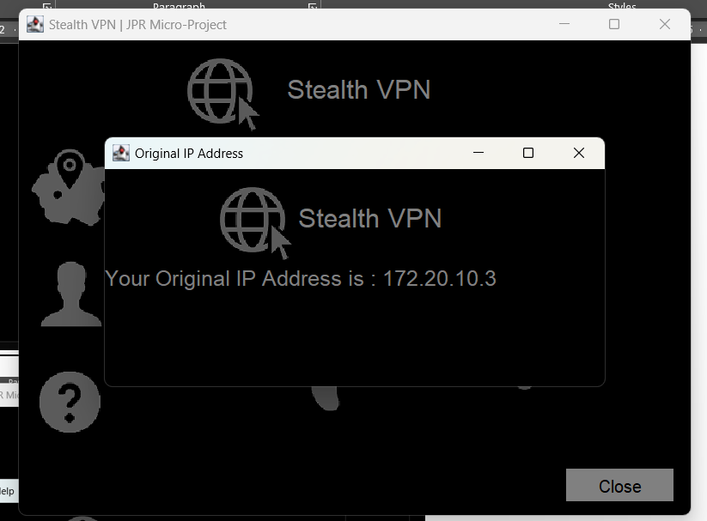

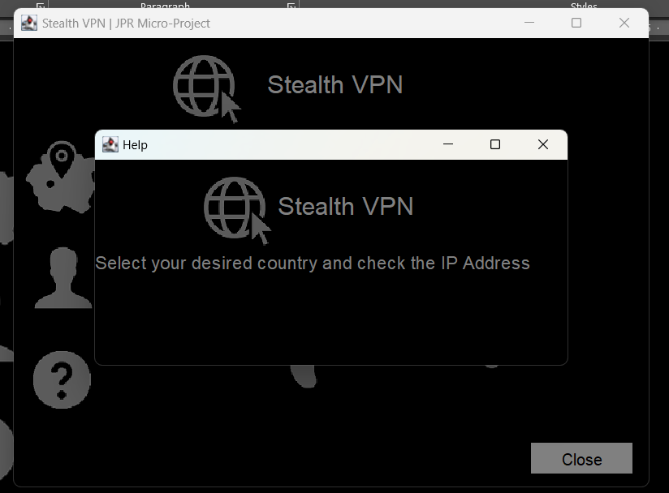

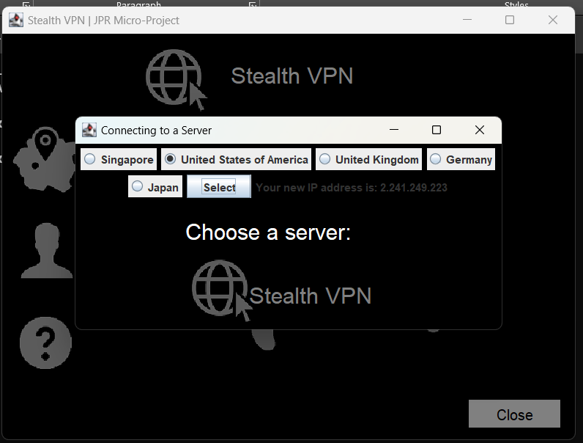

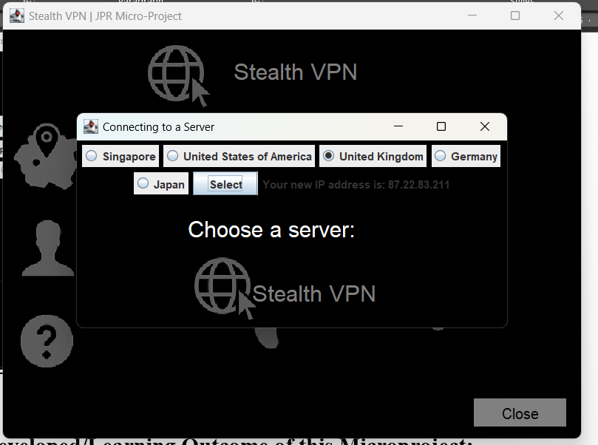

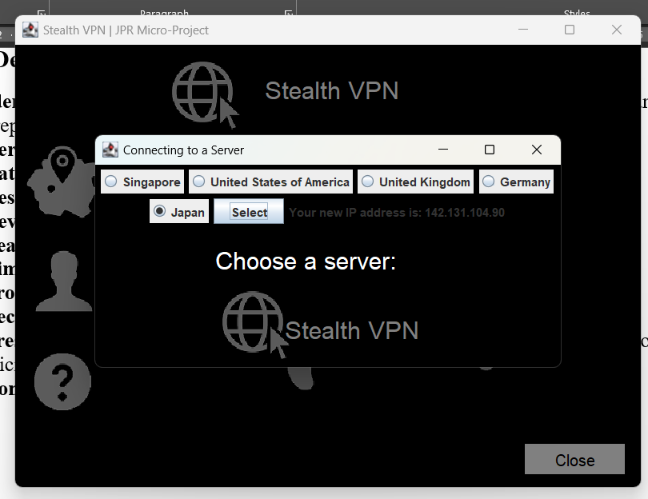

**8.0 Skill Developed/Learning Outcome of this Microproject:**

1. **Identifying:** Identifying the problem and cause of problem in the area related and prepare project proposals before starting the project.
2. **Derive:** Derive different possible solutions creatively.
3. **Data Collection:** Collect relevant data from different sources.
4. **Designing:** Designing of micro project with minimum required resources.
5. **Developing:** Develop the prototype/model/ of the desired project.
6. **Teamwork:** Learn to work in a team and boost individual confidence.
7. **Time Management:** Timely completion of micro project as scheduled.
8. **Problem-solving:** Develop good problem-solving skills.
9. **Technical Writing:** Preparing a report of the proposed plan and final report.
10. **Presentation and communication skills:** Giving working model presentation of the micro project.
11. **Confidence:** Confidently, answer the questions asked about the project.
12. **Acknowledgement:** Acknowledge the help rendered by others in the success of the project.

**9.0 Applications of this Microproject:**

* **Entertainment:** The primary application of a text-based adventure game is entertainment. By creating an engaging and immersive game, developers can provide players with a fun and engaging experience.
* **Educational:** Text-based adventure games can be used as an educational tool to teach programming concepts or other subjects. Developers can create a game that teaches players how to code in Java, for example, or that teaches history, literature, or other subjects through interactive storytelling.
* **Research:** Text-based adventure games can be used as a research tool to study player behavior, decision-making, and other aspects of human psychology. Researchers can use games to test hypotheses or explore different scenarios in a controlled environment.

**Annexure IV**

**MicroProjectEvaluationSheet**

**Name of Student: Abdullah Bagdadi Enrollment No: 2100020…**

**Name of Programme: CO Semester: 4th**

**Course Title: Java Programming Code: 22412**

**Title of the Micro-Project: Virtual private network (vpn) for an office**

**Course Outcomes Achieved: -**

1. Develop programs using Object oriented methodology in Java
2. Apply concept of inheritance for code reusability
3. Implement exception handling
4. Develop programs using multithreading

|  |  |  |  |  |  |  |
| --- | --- | --- | --- | --- | --- | --- |
| **Sr.**  **No.** | **Characteristics to be assessed** | **Poor (Marks 1**- **3)** | **Average (Marks4**-**5)** | **Good (Marks 6**-**8)** | **Excellent (Marks9-10)** | **Sub Total** |
| 1. Process and Product Assessment (Convert above total marks out of 6 Marks) | | | | | | |
| 1 | Relevance to the course |  |  |  |  |  |
| 2 | Literature Review/information  Collection |  |  |  |  |
| 3 | Completion of the Target as  Per project proposal |  |  |  |  |
| 4 | Analysis of Data and representation |  |  |  |  |
| 5 | Quality of Prototype/Model |  |  |  |  |
| 6 | Report Preparation |  |  |  |  |
|  | |
| 1. Individual Presentation/Viva (Convert above total marks out of 4 Marks) | | | | | | |
| 7 | Presentation |  |  |  |  |  |
| 8 | Viva |  |  |  |  |

**Comments/Suggestionsaboutteamwork/leadership/inter-personalcommunication**(if**any)**

**………………………………………………………………………………………………………………………………………………………………………………………………………………………………………………………………………………………………………………………………………………………**

**Nameanddesignation oftheTeacher …………………........................ DatedSignature……………………………………**

**Annexure IV**

**MicroProjectEvaluationSheet**

**Name of Student: Hussain Arsiwala Enrollment No: 2100020…**

**Name of Programme: CO Semester: 4th**

**Course Title: Java Programming Code: 22412**

**Title of the Micro-Project: Virtual private network (vpn) for an office**

**Course Outcomes Achieved: -**

1. Develop programs using Object oriented methodology in Java
2. Apply concept of inheritance for code reusability
3. Implement exception handling
4. Develop programs using multithreading

|  |  |  |  |  |  |  |
| --- | --- | --- | --- | --- | --- | --- |
| **Sr.**  **No.** | **Characteristics to be assessed** | **Poor (Marks 1**- **3)** | **Average (Marks4**-**5)** | **Good (Marks 6**-**8)** | **Excellent (Marks9-10)** | **Sub Total** |
| 1. Process and Product Assessment (Convert above total marks out of 6 Marks) | | | | | | |
| 1 | Relevance to the course |  |  |  |  |  |
| 2 | Literature Review/information  Collection |  |  |  |  |
| 3 | Completion of the Target as  Per project proposal |  |  |  |  |
| 4 | Analysis of Data and representation |  |  |  |  |
| 5 | Quality of Prototype/Model |  |  |  |  |
| 6 | Report Preparation |  |  |  |  |
|  | |
| 1. Individual Presentation/Viva (Convert above total marks out of 4 Marks) | | | | | | |
| 7 | Presentation |  |  |  |  |  |
| 8 | Viva |  |  |  |  |

**Comments/Suggestionsaboutteamwork/leadership/inter-personalcommunication**(if**any)**

**………………………………………………………………………………………………………………………………………………………………………………………………………………………………………………………………………………………………………………………………………………………**

**Nameanddesignation oftheTeacher …………………........................ DatedSignature……………………………………**

**Annexure IV**

**MicroProjectEvaluationSheet**

**Name of Student: Abdurrahman Qureshi Enrollment No: 2100020…**

**Name of Programme: CO Semester: 4th**

**Course Title: Java Programming Code: 22412**

**Title of the Micro-Project: Virtual private network (vpn) for an office**

**Course Outcomes Achieved: -**

1. Develop programs using Object oriented methodology in Java
2. Apply concept of inheritance for code reusability
3. Implement exception handling
4. Develop programs using multithreading

|  |  |  |  |  |  |  |
| --- | --- | --- | --- | --- | --- | --- |
| **Sr.**  **No.** | **Characteristics to be assessed** | **Poor (Marks 1**- **3)** | **Average (Marks4**-**5)** | **Good (Marks 6**-**8)** | **Excellent (Marks9-10)** | **Sub Total** |
| 1. Process and Product Assessment (Convert above total marks out of 6 Marks) | | | | | | |
| 1 | Relevance to the course |  |  |  |  |  |
| 2 | Literature Review/information  Collection |  |  |  |  |
| 3 | Completion of the Target as  Per project proposal |  |  |  |  |
| 4 | Analysis of Data and representation |  |  |  |  |
| 5 | Quality of Prototype/Model |  |  |  |  |
| 6 | Report Preparation |  |  |  |  |
|  | |
| 1. Individual Presentation/Viva (Convert above total marks out of 4 Marks) | | | | | | |
| 7 | Presentation |  |  |  |  |  |
| 8 | Viva |  |  |  |  |

**Comments/Suggestionsaboutteamwork/leadership/inter-personalcommunication**(if**any)**

**………………………………………………………………………………………………………………………………………………………………………………………………………………………………………………………………………………………………………………………………………………………**

**Nameanddesignation oftheTeacher …………………........................ DatedSignature……………………………………**

**ACKNOWLEDGMENT**

This micro project is done as a course project, as a part course titled

**“OBJECT ORIENTED PROGRAMMING**”

We are really thankful to our Course teacher **Ms. Zaibunnisa Malik** for his invaluable guidance and assistance, without which the accomplishment of the task would have never been possible We also thank our **Principal Dr. A. K. Kureshi , and HOD** for giving the opportunity to explore into the real world and realize the interrelation without which a Project can never progress. In our present project we have chosen the topic-

**“VIRTUAL PRIVATE NETWORK FOR OFFICE”**

We are also thankful to parents, friend and all staff of Computer Engineering Department, for providing us relevant information and necessary clarifications, and great support.

Student name: Hussain Arsiwala

Roll no:210448

Day: 1 Duration: 2 HR

Today, we were informed to form groups of three students for the JPR micro-project, we were required to create an enhancive microproject and ma’am specified that the group strength should not exceed more than three students. And told us to search the micro-project topic, the topic should be industry application based, internet-based, workshop-based, laboratory-based or field-based. And told that the micro-project should encompass two or more Cos which are in fact, an integration of PrOs, UOs, and ADOs. He also told the each group member will have to maintain a dated diary consisting of individual contribution in the project work. The total duration of the micro-project should not be less than 16 student engagement hours during the course. And the micro-project should be submitted before the end of the semester to develop the industry oriented Cos.

Following are my team-members:

* 1. Abdurrahman Qureshi (210451)
  2. Abdullah Baghdai(210422)
  3. Hussain Arsiwala(210448)

Day: 2 Duration: 2 HR

Today, we started searching the micro-project topic on the internet. We found many topics like College Management System, Hotel Billing System, Medical Store stock management system etc. We decided to work on VIRTUAL PRIVATE NETWORK FOR OFFICE. Ma’am explained to us the packages and classes to be made, the concept of various inheritance that should be considered and begin the work on micro-project. We started discussing the topics to be covered that has to be done to make the project complete. We decided to divide the work between us and work individually to make the project.

Day: 3 Duration: 2 HR

We were supposed to design the overall structure of the project and we were working on the actual code that has to be implemented. We decided to make different classes and using different keywords like super final in the classes.

Day: 4 Duration: 2 HR

Today, we decided to implement classes. We decided to use user defined exception, etc.

Day: 5 Duration: 2 HR

As we decided to make a different classes and packages such as login, student class, exam class so it became easy for us to divide the work. 1. Abdurrahman was implementing the user defined exception class was designing user defined package which will we further imported 3. Abdullah was implementing switch case and the final result class. And we decided to complete it on Day 6 and explain the code to everyone one. We started searching the best possible way that can be implemented.

Day: 6 Duration: 2 HR

I finally completed my work and explained the form to my fellow members. We compiled and interpreted the code .The code was error-free we got the output on our first attempt to run it. Now, the final work was to create a report on the micro-project which we decided to make on Day 7.

Day: 7 Duration: 2 HR

Ma’am instructed us the format of the report and according to it we started creating the report. Ma’am told us to submit the report on 22-03-2020. The report was completed and we took the hard copy of it.

Day: 8 Duration: 2 HR

We submitted the report. Creating such projects boosts our Communication skills, debugging skills. It also gives us an experience of how to work in a team.

**Student name:** Hussain Arsiwala

Student name: Abdurrahman Qureshi

Roll no:210451

Day: 1 Duration: 2 HR

Today, we were informed to form groups of three students for the JPR micro-project, we were required to create an enhancive microproject and ma’am specified that the group strength should not exceed more than three students. And told us to search the micro-project topic, the topic should be industry application based, internet-based, workshop-based, laboratory-based or field-based. And told that the micro-project should encompass two or more Cos which are in fact, an integration of PrOs, UOs, and ADOs. He also told the each group member will have to maintain a dated diary consisting of individual contribution in the project work. The total duration of the micro-project should not be less than 16 student engagement hours during the course. And the micro-project should be submitted before the end of the semester to develop the industry oriented Cos.

Following are my team-members:

* 1. Abdurrahman Qureshi (210451)
  2. Abdullah Baghdai(210422)
  3. Hussain Arsiwala(210448)

Day: 2 Duration: 2 HR

Today, we started searching the micro-project topic on the internet. We found many topics like College Management System, Hotel Billing System, Medical Store stock management system etc. We decided to work on VIRTUAL PRIVATE NETWORK FOR OFFICE. Ma’am explained to us the packages and classes to be made, the concept of various inheritance that should be considered and begin the work on micro-project. We started discussing the topics to be covered that has to be done to make the project complete. We decided to divide the work between us and work individually to make the project.

Day: 3 Duration: 2 HR

We were supposed to design the overall structure of the project and we were working on the actual code that has to be implemented. We decided to make different classes and using different keywords like super final in the classes.

Day: 4 Duration: 2 HR

Today, we decided to implement classes. We decided to use user defined exception, etc.

Day: 5 Duration: 2 HR

As we decided to make a different classes and packages such as login, student class, exam class so it became easy for us to divide the work. 1. Abdurrahman was implementing the user defined exception class was designing user defined package which will we further imported 3. Abdullah was implementing switch case and the final result class. And we decided to complete it on Day 6 and explain the code to everyone one. We started searching the best possible way that can be implemented.

Day: 6 Duration: 2 HR

I finally completed my work and explained the form to my fellow members. We compiled and interpreted the code .The code was error-free we got the output on our first attempt to run it. Now, the final work was to create a report on the micro-project which we decided to make on Day 7.

Day: 7 Duration: 2 HR

Ma’am instructed us the format of the report and according to it we started creating the report. Ma’am told us to submit the report on 22-03-2020. The report was completed and we took the hard copy of it.

Day: 8 Duration: 2 HR

We submitted the report. Creating such projects boosts our Communication skills, debugging skills. It also gives us an experience of how to work in a team.

**Student name:** Abdurrahman Qureshi

**Student name:** Abdullah Baghdadi

**Roll no:**210422

Day: 1 Duration: 2 HR

Today, we were informed to form groups of three students for the JPR micro-project, we were required to create an enhancive microproject and ma’am specified that the group strength should not exceed more than three students. And told us to search the micro-project topic, the topic should be industry application based, internet-based, workshop-based, laboratory-based or field-based. And told that the micro-project should encompass two or more Cos which are in fact, an integration of PrOs, UOs, and ADOs. He also told the each group member will have to maintain a dated diary consisting of individual contribution in the project work. The total duration of the micro-project should not be less than 16 student engagement hours during the course. And the micro-project should be submitted before the end of the semester to develop the industry oriented Cos.

Following are my team-members:

* 1. Abdurrahman Qureshi (210451)
  2. Abdullah Baghdai(210422)
  3. Hussain Arsiwala(210448)

Day: 2 Duration: 2 HR

Today, we started searching the micro-project topic on the internet. We found many topics like College Management System, Hotel Billing System, Medical Store stock management system etc. We decided to work on **VIRTUAL PRIVATE NETWORK FOR OFFICE**. Ma’am explained to us the packages and classes to be made, the concept of various inheritance that should be considered and begin the work on micro-project. We started discussing the topics to be covered that has to be done to make the project complete. We decided to divide the work between us and work individually to make the project.

Day: 3 Duration: 2 HR

We were supposed to design the overall structure of the project and we were working on the actual code that has to be implemented. We decided to make different classes and using different keywords like super final in the classes.

Day: 4 Duration: 2 HR

Today, we decided to implement classes. We decided to use user defined exception, etc.

Day: 5 Duration: 2 HR

As we decided to make a different classes and packages such as login, student class, exam class so it became easy for us to divide the work. 1. **Abdurrahman** was implementing the user defined exception class was designing user defined package which will we further imported 3. **Abdullah** was implementing switch case and the final result class. And we decided to complete it on Day 6 and explain the code to everyone one. We started searching the best possible way that can be implemented.

Day: 6 Duration: 2 HR

I finally completed my work and explained the form to my fellow members. We compiled and interpreted the code .The code was error-free we got the output on our first attempt to run it. Now, the final work was to create a report on the micro-project which we decided to make on Day 7.

Day: 7 Duration: 2 HR

Ma’am instructed us the format of the report and according to it we started creating the report. Ma’am told us to submit the report on 22-03-2020. The report was completed and we took the hard copy of it.

Day: 8 Duration: 2 HR

We submitted the report. Creating such projects boosts our Communication skills, debugging skills. It also gives us an experience of how to work in a team.

**Student name:** Abdullah Baghdadi